**PROBLEMA 1**

1. Relación entre el sistema binario y lógica de dos niveles eléctricos.

El sistema binario solo admite dos valores, 0 ó 1, mientras que un circuito de dos niveles las variables pueden tomar un valor de verdad (encendido ó apagado).

1. 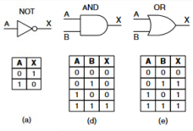Las 3 funciones elementales lógicas son:

* AND
* OR
* NOT

1. Las tres maneras posibles es a través de la tabla de verdad, que muestra el valor de verdad de una proposición compuesta para cada combinación de verdad que se pueda asignar; luego está la función booleana que describe el circuito y que representa a la tabla de verdad, y por último el diagrama o esquemática que lo representa en sí mismo al circuito.

**PROBLEMA 2**

Circuito equivalente a la compuerta XOR:

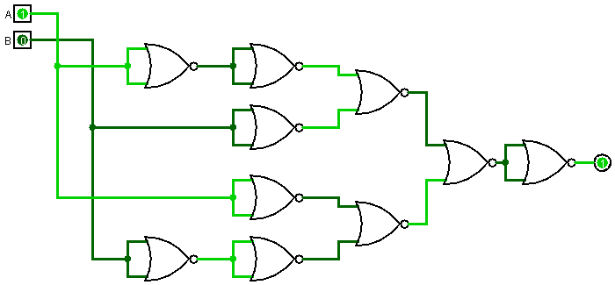

**PROBLEMA 3**

a) f(A,B,C) = A*/B*/C + /A*B*/C + /A*/B*C + A*B*C

|  |  |  |  |
| --- | --- | --- | --- |
| A | B | C | F |
| 0 | 0 | 0 | 0 |
| 0 | 0 | 1 | 1 |
| 0 | 1 | 0 | 1 |
| 0 | 1 | 1 | 0 |
| 1 | 0 | 0 | 1 |
| 1 | 0 | 1 | 0 |
| 1 | 1 | 0 | 0 |
| 1 | 1 | 1 | 1 |

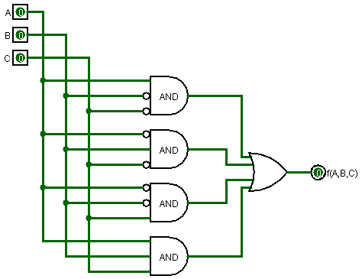

b) f(A,B,C) = /A*/B*/C + A*/B*C

|  |  |  |  |
| --- | --- | --- | --- |
| A | B | C | F |
| 0 | 0 | 0 | 1 |
| 0 | 0 | 1 | 0 |
| 0 | 1 | 0 | 0 |
| 0 | 1 | 1 | 0 |
| 1 | 0 | 0 | 0 |
| 1 | 0 | 1 | 1 |
| 1 | 1 | 0 | 0 |
| 1 | 1 | 1 | 0 |

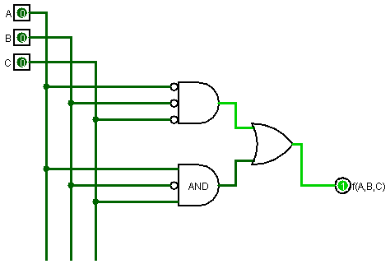

c) f(A,B,C,D) = A*B*/C*D + A*/B*C*/D + /A*/B*/C*/D

|  |  |  |  |  |
| --- | --- | --- | --- | --- |
| A | B | C | D | F |
| 0 | 0 | 0 | 0 | 1 |
| 0 | 0 | 0 | 1 | 0 |
| 0 | 0 | 1 | 0 | 0 |
| 0 | 0 | 1 | 1 | 0 |
| 0 | 1 | 0 | 0 | 0 |
| 0 | 1 | 0 | 1 | 0 |
| 0 | 1 | 1 | 0 | 0 |
| 0 | 1 | 1 | 1 | 0 |
| 1 | 0 | 0 | 0 | 0 |
| 1 | 0 | 0 | 1 | 0 |
| 1 | 0 | 1 | 0 | 1 |
| 1 | 0 | 1 | 1 | 0 |
| 1 | 1 | 0 | 0 | 0 |
| 1 | 1 | 0 | 1 | 1 |
| 1 | 1 | 1 | 0 | 0 |
| 1 | 1 | 1 | 1 | 0 |

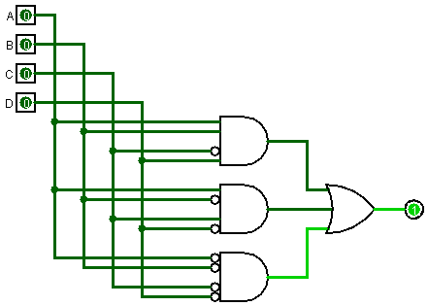

**PROBLEMA 4**

|  |  |  |  |
| --- | --- | --- | --- |
| A | B | C | F |
| 0 | 0 | 0 | 0 |
| 0 | 0 | 1 | 1 |
| 0 | 1 | 0 | 1 |
| 0 | 1 | 1 | 0 |
| 1 | 0 | 0 | 1 |
| 1 | 0 | 1 | 0 |
| 1 | 1 | 0 | 0 |
| 1 | 1 | 1 | 0 |

1. f(A,B,C) = (/A * /B * C) + (/A * B * /C) + (A * /B * /C) **FND-Suma de Productos**

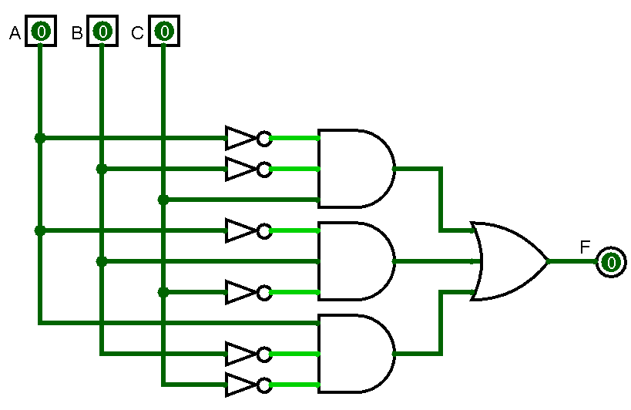

F(A,B,C)=(A+B+C)*(A+/B+/C)*(/A+B+/C)*(/A+/B+C)*(/A+/B+/C) **FNC- Producto de sumas**

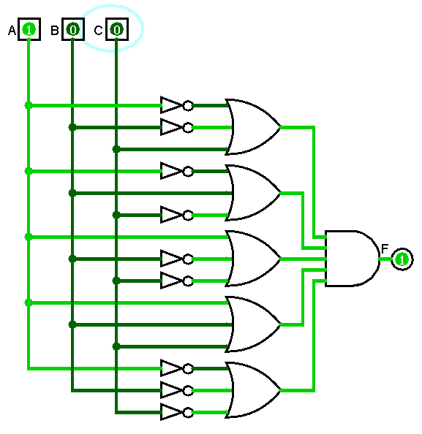

|  |  |  |  |
| --- | --- | --- | --- |
| A | B | C | F |
| 0 | 0 | 0 | 1 |
| 0 | 0 | 1 | 1 |
| 0 | 1 | 0 | 0 |
| 0 | 1 | 1 | 0 |
| 1 | 0 | 0 | 1 |
| 1 | 0 | 1 | 1 |
| 1 | 1 | 0 | 1 |
| 1 | 1 | 1 | 0 |

1. f(A,B,C) = (/A * /B * /C) + (/A * /B * C) + (A * /B * /C) + (A * /B * C) + (A * B * /C) **FND-Suma de Prod**

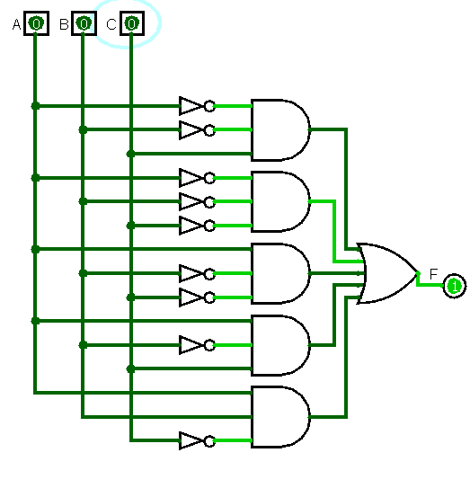

f(A,B,C) = (A +/B +C) *(A + /B + /C)*(/A + /B + /C) **FNC- Producto de Sumas**

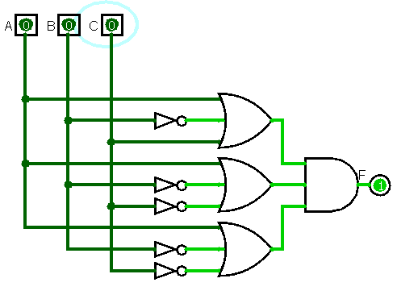

|  |  |  |  |
| --- | --- | --- | --- |
| A | B | C | F |
| 0 | 0 | 0 | 0 |
| 0 | 0 | 1 | 1 |
| 0 | 1 | 0 | 1 |
| 0 | 1 | 1 | 0 |
| 1 | 0 | 0 | 1 |
| 1 | 0 | 1 | 0 |
| 1 | 1 | 0 | 0 |
| 1 | 1 | 1 | 1 |

1. f(A,B,C) = (A+/B+/C) *(/A+B+/C) * (/A+/B+C) * (A+B+C) **FNC- Producto de Sumas**

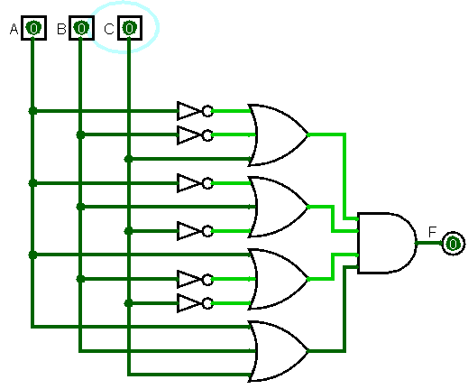

f(A,B,C) = (/A*/B*C) + (/A*B*/C) + (A*/B*/C) + (A*B*C) **FND- Suma de Productos**

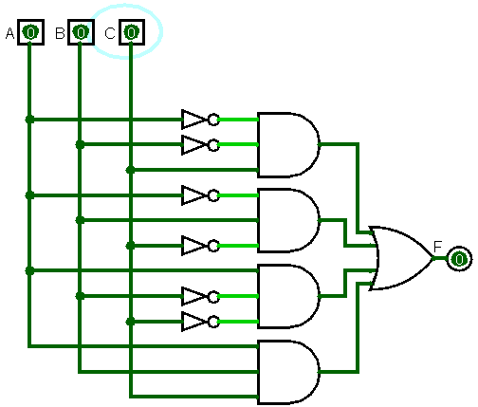

|  |  |  |  |  |
| --- | --- | --- | --- | --- |
| A | B | C | D | F |
| 0 | 0 | 0 | 0 | 1 |
| 0 | 0 | 0 | 1 | 1 |
| 0 | 0 | 1 | 0 | 1 |
| 0 | 0 | 1 | 1 | 1 |
| 0 | 1 | 0 | 0 | 1 |
| 0 | 1 | 0 | 1 | 0 |
| 0 | 1 | 1 | 0 | 1 |
| 0 | 1 | 1 | 1 | 1 |
| 1 | 0 | 0 | 0 | 1 |
| 1 | 0 | 0 | 1 | 1 |
| 1 | 0 | 1 | 0 | 0 |
| 1 | 0 | 1 | 1 | 1 |
| 1 | 1 | 0 | 0 | 1 |
| 1 | 1 | 0 | 1 | 1 |
| 1 | 1 | 1 | 0 | 1 |
| 1 | 1 | 1 | 1 | 0 |

1. f(A,B,C,D) = (/A+B+/C+D) * (A+/B+C+/D) * (/A+/B+/C+/D) **FNC- Producto de Sumas**

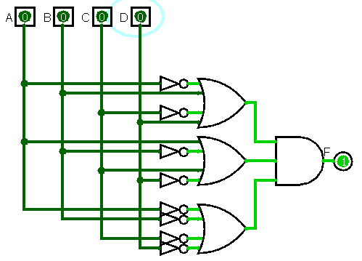

f(A,B,C) = (A*B*C*D)+ (A*B*C*/D)+ (A*B*/C*D)+ (A*/B*C*D)+ (A*B*/C*/D)+ (A*/B*/C*D)+ (A*/B*/C*/D)+ (/A*B*C*D)+ (/A*B*/C*/D)+ (/A*/B*C*D)+ (/A*/B*C*/D)+ (/A*/B*/C*D)+ (/A*B*C*/D) **FND- Suma de Productos**

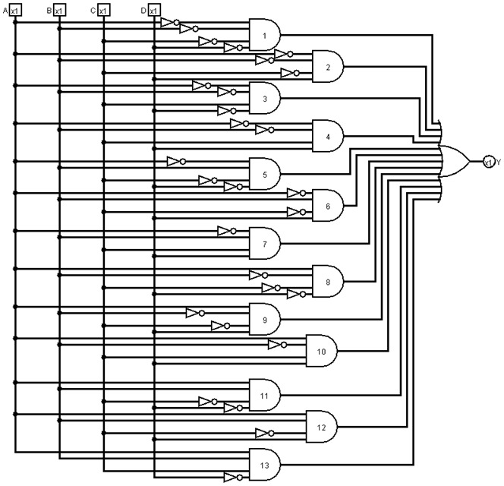

**PROBLEMA 5**

a)

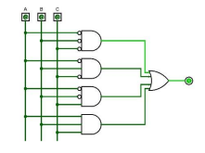

f(A,B,C) = (A’ B’ C’) + (A’ B C’) + (A’ B’ C) + (A B C)

|  |  |  |  |
| --- | --- | --- | --- |
| A | B | C | F |
| 0 | 0 | 0 | 1 |
| 0 | 0 | 1 | 0 |
| 0 | 1 | 0 | 1 |
| 0 | 1 | 1 | 0 |
| 1 | 0 | 0 | 0 |
| 1 | 0 | 1 | 0 |
| 1 | 1 | 0 | 1 |
| 1 | 1 | 1 | 1 |

b)

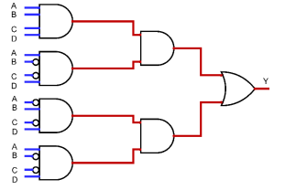

f(A,B,C,D) = (A B C D)*(A B’ C’ D) + (A’ B C’ D)*(A B’ C’ D)

f(A,B,C,D) = (A B’ C’ D) * [ ( A B C D) + (A’ B C’ D) ]

f(A,B,C,D) = 0

|  |  |  |  |  |
| --- | --- | --- | --- | --- |
| A | B | C | D | F |
| 0 | 0 | 0 | 0 | 0 |
| 0 | 0 | 0 | 1 | 0 |
| 0 | 0 | 1 | 0 | 0 |
| 0 | 0 | 1 | 1 | 0 |
| 0 | 1 | 0 | 0 | 0 |
| 0 | 1 | 0 | 1 | 0 |
| 0 | 1 | 1 | 0 | 0 |
| 0 | 1 | 1 | 1 | 0 |
| 1 | 0 | 0 | 0 | 0 |
| 1 | 0 | 0 | 1 | 0 |
| 1 | 0 | 1 | 0 | 0 |
| 1 | 0 | 1 | 1 | 0 |
| 1 | 1 | 0 | 0 | 0 |
| 1 | 1 | 0 | 1 | 0 |
| 1 | 1 | 1 | 0 | 0 |
| 1 | 1 | 1 | 1 | 0 |

**PROBLEMA 6**

|  |  |  |  |  |
| --- | --- | --- | --- | --- |
| A | B | C | D | F |
| 0 | 0 | 0 | 0 | 0 |
| 0 | 0 | 0 | 1 | 0 |
| 0 | 0 | 1 | 0 | 0 |
| 0 | 0 | 1 | 1 | 0 |
| 0 | 1 | 0 | 0 | 0 |
| 0 | 1 | 0 | 1 | 1 |
| 0 | 1 | 1 | 0 | 0 |
| 0 | 1 | 1 | 1 | 1 |
| 1 | 0 | 0 | 0 | 0 |
| 1 | 0 | 0 | 1 | 0 |
| 1 | 0 | 1 | 0 | 1 |
| 1 | 0 | 1 | 1 | 0 |
| 1 | 1 | 0 | 0 | 0 |
| 1 | 1 | 0 | 1 | 1 |
| 1 | 1 | 1 | 0 | 0 |
| 1 | 1 | 1 | 1 | 0 |

F(A,B,C,D)=(/A*/B*C*/D)+(/A*/B*C*D) +(/A*B*C*D) +(A*/B*C*/D) +(A*B*/C*D)

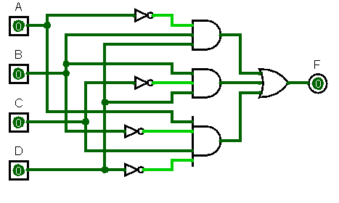

**PROBLEMA 7**

|  |  |  |  |  |
| --- | --- | --- | --- | --- |
| A | B | C | D | F |
| 0 | 0 | 0 | 0 | 1 |
| 0 | 0 | 0 | 1 | 1 |
| 0 | 0 | 1 | 0 | 1 |
| 0 | 0 | 1 | 1 | 1 |
| 0 | 1 | 0 | 0 | 0 |
| 0 | 1 | 0 | 1 | 1 |
| 0 | 1 | 1 | 0 | 0 |
| 0 | 1 | 1 | 1 | 0 |
| 1 | 0 | 0 | 0 | 1 |
| 1 | 0 | 0 | 1 | 0 |
| 1 | 0 | 1 | 0 | 0 |
| 1 | 0 | 1 | 1 | 0 |
| 1 | 1 | 0 | 0 | 0 |
| 1 | 1 | 0 | 1 | 1 |
| 1 | 1 | 1 | 0 | 0 |
| 1 | 1 | 1 | 1 | 0 |

F(A,B,C,D)=(/A*/B)+(/A*B*/C*D) +(/A*/B*/C*/D) +(A*/B*/C*/D) +(A*B*/C*D)

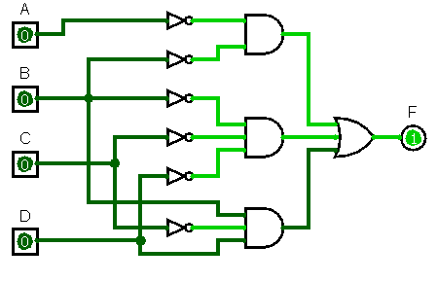

**PROBLEMA 8**

Postulados de Huntington y propiedades: 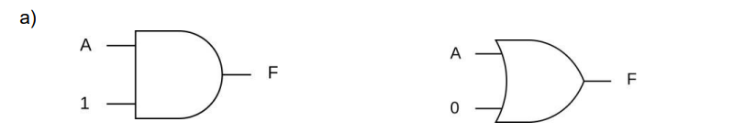Ley de identidad

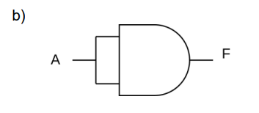Ley de Idempotencia

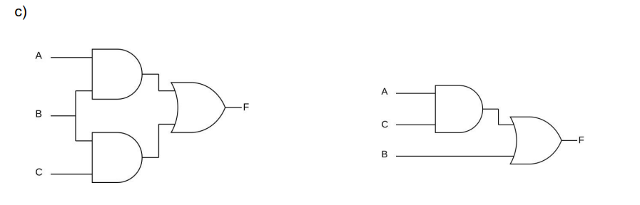Ley distributiva

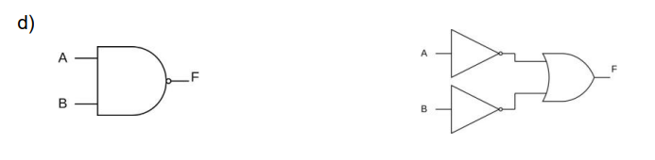Ley de Morgan

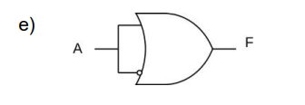

Ley inversa o ley de complementación

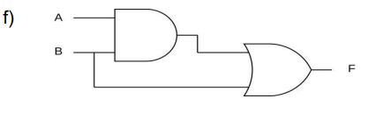  
  
  
  
  
  
  
Ley de absorción

**PROBLEMA 9**

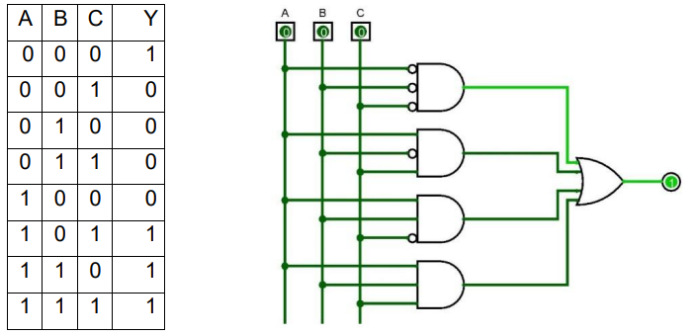

OR CON NOR

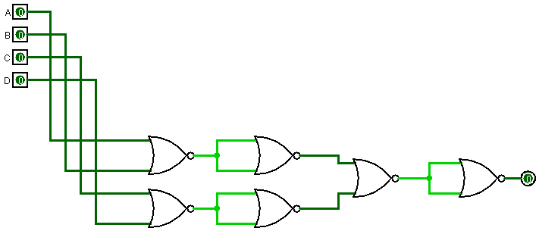

NOT CON OR 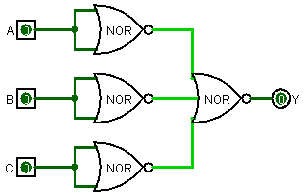AND CON NOR

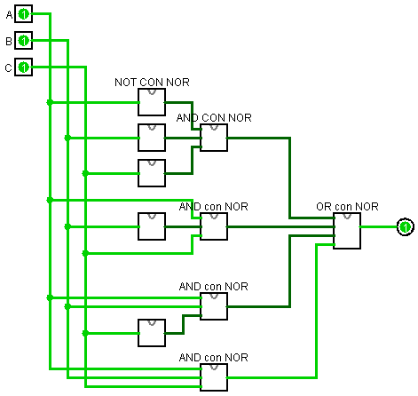Circuito equivalente implementado con compuertas NOR:

**PROBLEMA 10**

De las siguientes tablas de verdad, realice el circuito más óptimo correspondiente y su función booleana.

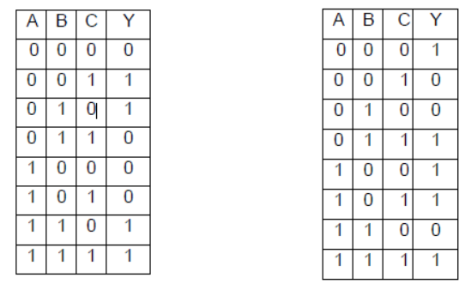

a) f(A,B,C) = (A’B’C) + (A’BC’) + (ABC’) + (ABC)

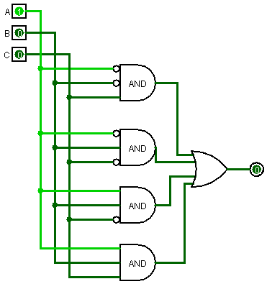

b) f(A,B,C) = (A+B+C’)*(A+B’+C)*(A’+B’+C)

